WEB APPLICATION PENETRATION TESTING

Authentication Assessment Report
2FA Simple Bypass
PortSwigger Web Security Academy | Burp Suite / Browser

1. Executive Summary
This assessment documents the PortSwigger Web Security Academy lab “2FA simple bypass”. The supplied evidence shows a security-code email being delivered to the test mailbox, followed by navigation to the account endpoint with the account identifier set to “carlos”. The lab then displayed its success confirmation. This indicates that the application's account-access flow did not adequately enforce the intended two-factor authentication boundary for the demonstrated request sequence.

2. Scope and Objective
Scope: the intentionally vulnerable PortSwigger Web Security Academy lab environment. Objective: assess whether the two-factor authentication flow can be bypassed and whether an account page can be reached without the expected verification being enforced.
This report is limited to the supplied lab evidence and does not establish that any production application has the same weakness.

3. Tools and Evidence Sources
- Web browser — navigating the lab authentication flow and account endpoint.
- PortSwigger-provided email client / exploit server — viewing the security-code email.
- PortSwigger Web Security Academy — confirming that the lab was solved.

4. Technical Analysis
The email evidence shows that the lab generated a security-code message for the wiener test mailbox. The subsequent URL evidence shows navigation to /my-account?id=carlos. The final screenshot displays the account page for carlos together with the lab's “Congratulations, you solved the lab!” confirmation.
Taken together, these screenshots support the conclusion that the lab's 2FA/account access flow could be bypassed to reach the carlos account. The screenshots do not show every intermediate request or response, so this report does not claim a specific server-side implementation defect beyond the observed access-control failure.

5. Evidence
Evidence is arranged in the order supplied. The one-time security code, email address, and unique lab-host token have been redacted in the report copies.
Figure 1 — Security-code email
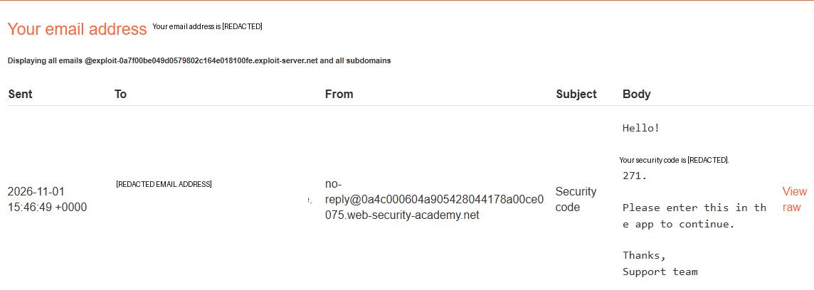
The lab email client displays a security-code email sent to the test mailbox. The one-time code is redacted.
Figure 2 — Navigation to the target account
The browser address shows the account endpoint with id=carlos.
Figure 3 — Lab completion
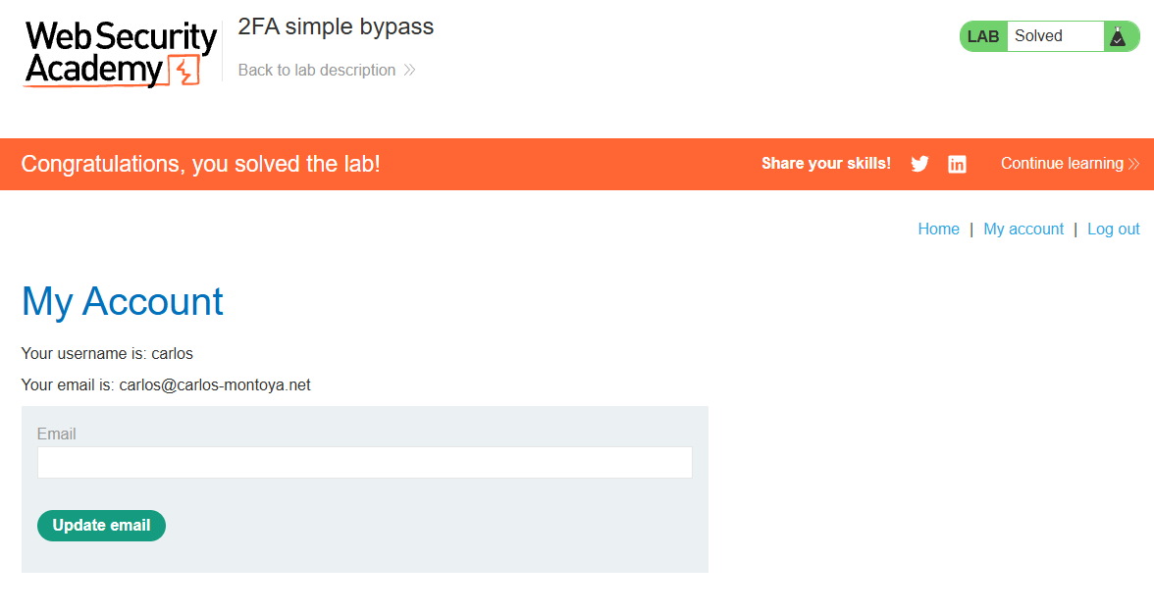
The account page identifies carlos and the PortSwigger interface confirms that the lab is solved.

6. Impact
A weakness that allows a user to reach protected account functionality without successfully completing the required second factor undermines the purpose of MFA. Depending on the affected application and account privileges, this may expose unauthorised account information or functionality. The demonstrated impact here is limited to the PortSwigger lab account.

7. Risk and Classification
No numerical CVSS score is assigned. The screenshots confirm lab completion but do not provide enough information about the full application, privileges, or production impact to calculate a defensible real-world score.
Relevant security concepts: improper enforcement of multi-factor authentication and broken access control. A more specific CWE mapping would require inspection of the underlying request flow and server-side authorization logic.

8. Recommendations
- Enforce successful second-factor verification on the server before granting access to protected account resources.
- Bind the verified authentication state to the authenticated user and session; do not rely on client-side navigation or URL parameters.
- Derive the account identity from the authenticated server-side session rather than trusting a user-controlled account identifier.
- Apply authorization checks on every account endpoint and object reference.
- Invalidate or restrict partially authenticated sessions until MFA verification is complete.
- Log and monitor attempts to access protected resources before MFA completion.

9. Conclusion
The supplied evidence shows that the lab's authentication flow allowed access to the carlos account and returned the lab success confirmation. The key defensive requirement is server-side enforcement of MFA completion and account-level authorization on every protected request.

10. Reference
PortSwigger Web Security Academy — Authentication vulnerabilities:
https://portswigger.net/web-security/authentication

Disclaimer
This exercise was conducted in an intentionally vulnerable training environment provided by PortSwigger Web Security Academy. These techniques must only be used against systems for which explicit authorisation has been obtained.

